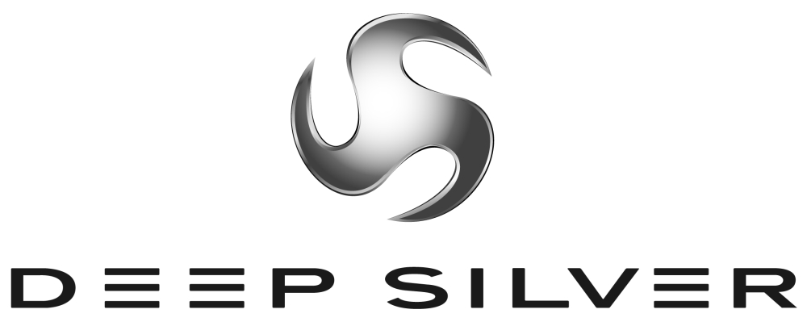
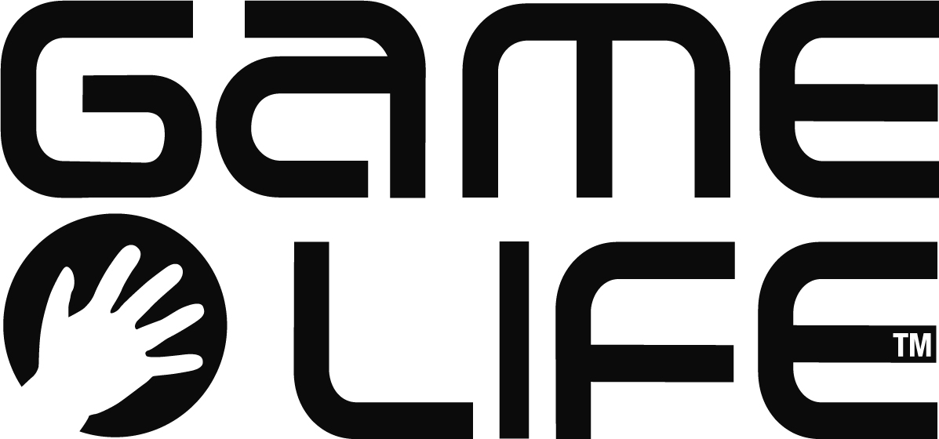
Press Information
Planegg/Germany, Paris/France, August 2008
International Press Contact:
Martin Metzler
Koch Media GmbH Tel: +49 89 24245-123
Lochhamerstr. 9 Fax: +49 89 24245-3 134
82152 Planegg/München m.metzler@kochmedia.com

Deep Silver and Game Life announce The Magic Roundabout

Television license to be implemented on Nintendo DS, Wii and PC

Deep Silver, the games label of Koch Media, a leading producer and distributor of digital entertainment products, and French publisher Game Life today announced a game based on the popular children's TV series "The Magic Roundabout" for Nintendo DS™, Wii™ and PC. Koch Media owns the publishing rights for all PAL territories.

All the well-known characters of the series will appear in a typical, humorous story created especially for the game: the magician Zebedee, the shaggy dog Dougal, Florence the adorable girl, Ermintrude, the pink cow with red spots, and many more. On Friendship Day, Zebedee promises Dougal a valuable gift if he is able to help everyone in the village.

The world of the “The Magic Roundabout” is brought to life in a number of mini-games and bonus missions with lovingly designed graphics. The game makes creative use of the different platforms' unique controls: for example, players control the flight of a paper plane by blowing into the microphone of the Nintendo DS, or uncover hidden objects by "shaking" the mouse cursor on the PC, or the Wii Remote in the Wii version.

"Over the years, the series has developed into a real classic of children's television, and thanks to a new release and a feature movie, it is still popular with people of all ages," says Dr. Klemens Kundratitz, CEO of Koch Media. "With its charm and diversity, the game does justice to the popular series on which it is based on every platform."

“The Magic Roundabout” will be released for Nintendo DS, Wii and PC in the fourth quarter of 2008.

About Deep Silver
Deep Silver develops and distributes interactive games for all platforms. The Deep Silver label means to captivate all computer and video gamers who enjoy and share a passion for thrilling gameplay in modern game worlds. Deep Silver works with its part-ners to achieve a maximum of success while maintaining the highest possible quality, always focusing on what the customer desires. Deep Silver products are designed to equally appeal to professionals and beginners, children and adults.

Deep Silver has published around 40 games since 2003, including the most successful adventure of 2006, Secret Files: Tun-guska, the bestseller ANNO 1701 (co-published with Sunflowers), the challenging CrossworDS knowledge puzzle game, the horse simulation Horse Life DS, and the soccer MMO World of Soccer Online. Current developments include Warhammer® - Battle March™ (in cooperation with Namco Bandai), the action role-playing game Sacred 2: Fallen Angel (in cooperation with Ascaron), S.T.A.L.K.E.R.: Clear Sky, the sinister Chernobyl shooter for PC, and the new game from the Piranha Bytes team. Deep Silver's own developing studio Deep Silver Vienna opened in 2007. For more information please visit www.deepsilver.com

Koch Media is a leading producer and distributor of digital entertainment products (software, games and movies on DVD). The company's own sales activities, marketing and distribution extend throughout Europe, and it has formed strategic alliances with numerous software and games manufacturers: Ascaron, Braingame, D3P, G-Data, Gamelife, Kaspersky Lab, Lexware, Namco Bandai, Pinnacle, Square Enix, Sony Online Entertainment, System3, etc. Headquartered in Planegg near Munich/Germany, Koch Media owns publishing and distribution branches in Germany, England, France, Austria, Switzerland, Italy and the USA. www.kochmedia.com

About GAME LIFE
Game Life is a dynamic independent videogame publisher, willing to release games with original concept, that are simply easy and fun to play. Game Life develop quality content and licenses on a worldwide basis, and focus our activities on next generation console games, willing to offer a product portfolio of AAA titles.

NINTENDO DS, Wii AND THE Wii LOGO ARE TRADEMARKS OF NINTENDO.

